

task 4

DATA BASE MANAGEMENT SYSTEM



March 30, 2023

**AKHTAR ALI**

**34241**

**BSSE**

**Submitted to Sir Waris Ali**

* Query1: Create tabel of emloyee?
* create table employee(empno number, name varchar(25));
* insert into employee(empno,name)

select empno,ename from emp;

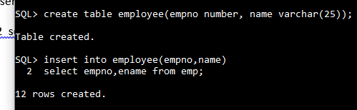

* Query 2:
* create table abc(nam,job,salary) as select ename,job,sal from emp

where job ='CLERK';

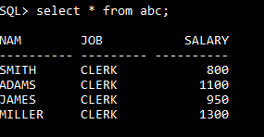

* Query 3:
* select sal,comm,NVL(comm,0) from emp;

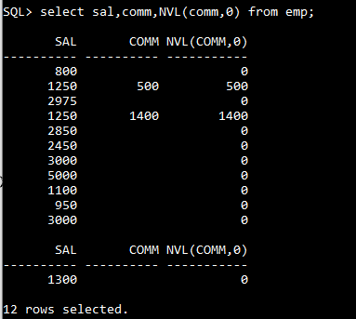

* Query 4:
* select sal,comm,sal+NVL(comm,0) from emp;

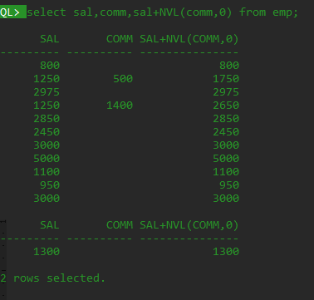

* Query 5:
* select sal,comm,NVL2(comm,sal+comm,sal) from emp;

work like if else statement.

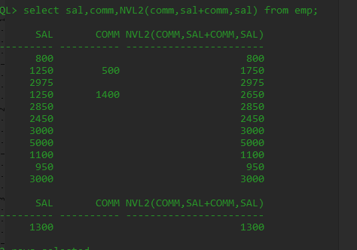

* select ASCII('A'),ASCII('B'),ASCII('C') from dual;

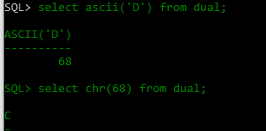

* select chr(68),chr(70) from dual;

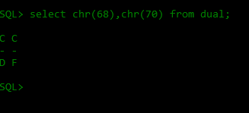

* Query 6:Display initicap first letter capital:

select initcap(ename),initcap('fine') from emp;

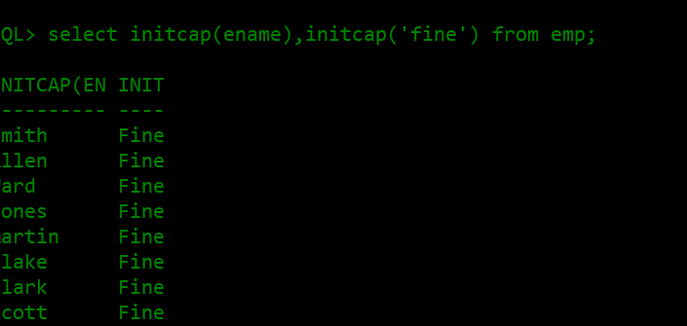

* Query 7:Display position of the string

select ename,INSTR(ename,'S') from emp;

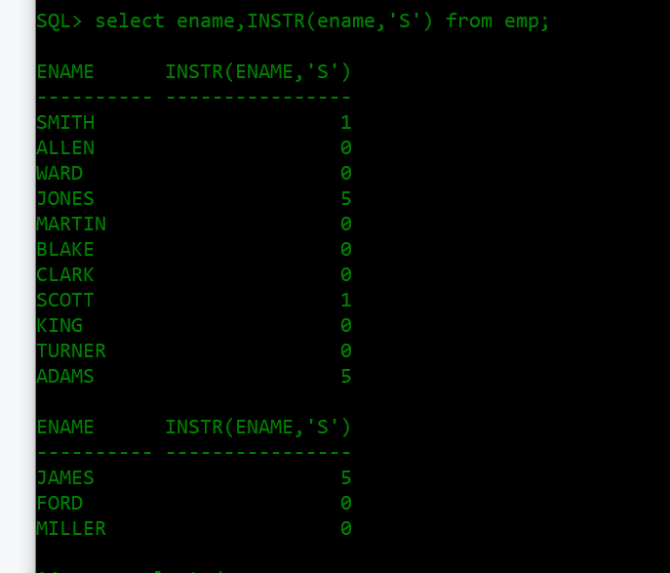

* Query 8:Display the string position starting position and final position
* select INSTR('mississipi','i',3,3) from dual;

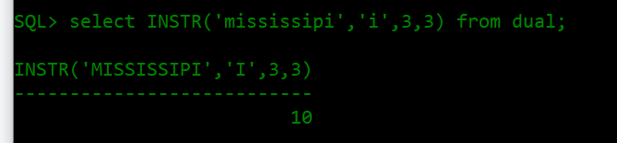

* select INSTR('mississipi','i',3,1) from dual;

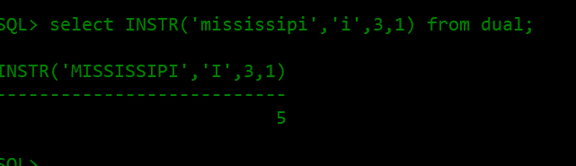

* select INSTR('mississipi','i',1,3) from dual;

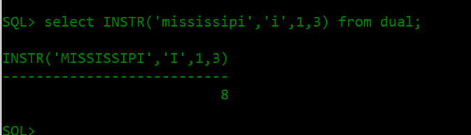

* Query 9:display string position from forward;

select ename,instr(ename,'n'),instr('mississippi','i',3,3) from emp;

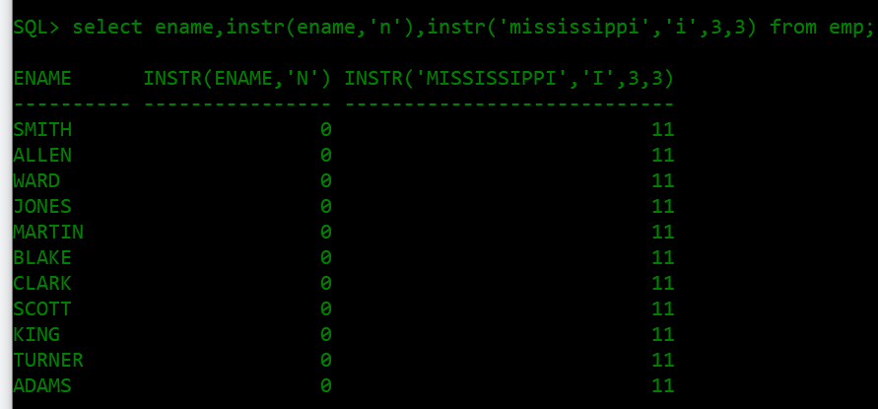

* Query 10:display string position from backward;(-3 mean u should count string from backward)

select ename,instr(ename,'n'),instr('mississippi','i',-3,3) from emp;

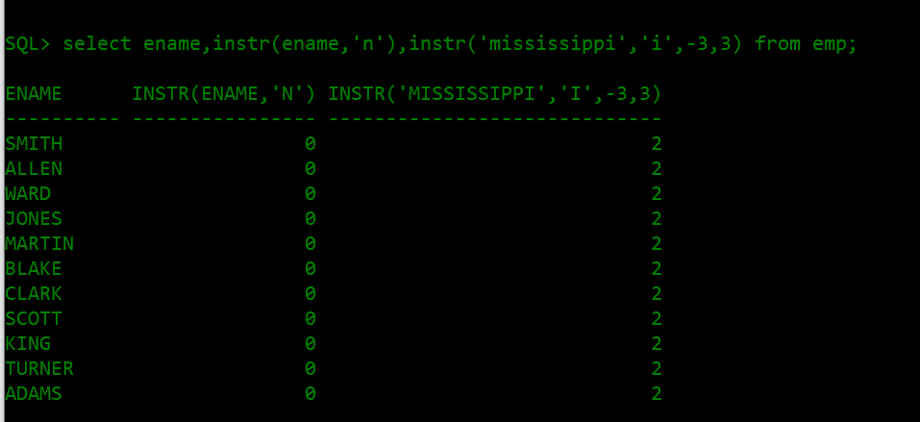

* Query 11:lower and upper case.Display all capital letter in upper case and all smaller in lower case?

select ename NAME, upper(ename) ALL_CAPITAL,lower (ename) ALL_SMAL, initcap(ename) from emp;

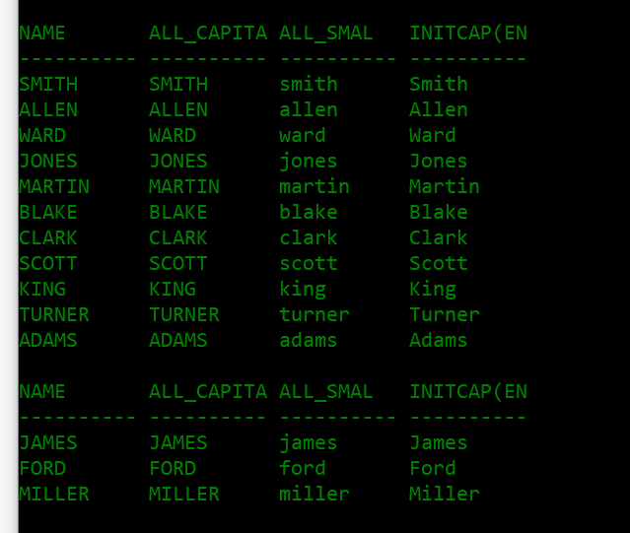

* Query 12:

select substr(ename,1,4) substring from emp;

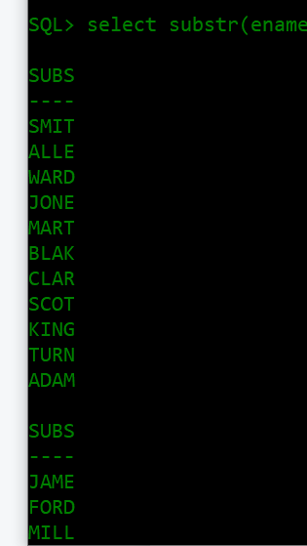

* Query 13:Round about(number function)

select round(45.923,3),round(45.923,0),round(45.923,-1) from dual;

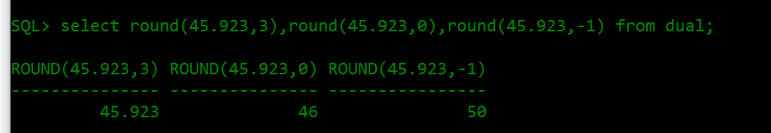

* Query 14:remove last digit?

select trunc(2845.926,-2),trunc(2845.926,-3),trunc(2845.926,-1) from dual;

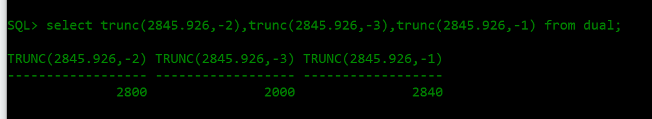

* Query 15:

select trunc(2845.926,0),trunc(2845.926,1),trunc(2845.926,2) from dual;

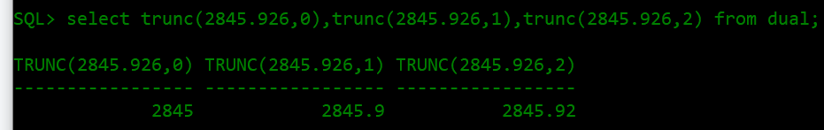

* Query 16: Display the modulus

select ename,sal,MOD(sal,10),MOD(sal,50),MOD(sal,500) from emp;

